Gyubeom Kim

INFO 498

Randal Root

2018/08/09

**Assignment5**

For the fifth assignment of one of my academic courses, INFO 498, I created a SQL Server Agent Job called ‘RefreshNorthwindReports’. The created job would back up the Northwind Database and restore a copy of it for the process of reporting. Also, I posted a blog for the procedure of creating SQL Agent Job that I performed for the assignment.

**Create a New SQL Server Agent Job:**

To begin with, I started to create a new SQL server Agent Job. As I clicked the plus to expand SQL Server Agent, I was able to see the Job folder where I created a new job as the picture shown below.

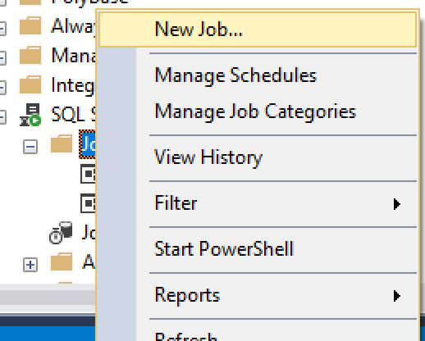

**Setting for a New Job:**

For the next task, I configured for a SQL Job as the picture shown below. I firstly changed default name for the Job to “RefreshNorthwindReports” and category for Database Maintenance. I also changed the owner to SA (System Administrator). The reason I changed like this is to use my job on another computer. If I set owner as my computer name and use another computer for using the job, it may not work. Then, I wrote about what my created job does. To be more specific, through using a job, I would back up the Northwind database and restore a copy of it for reporting.

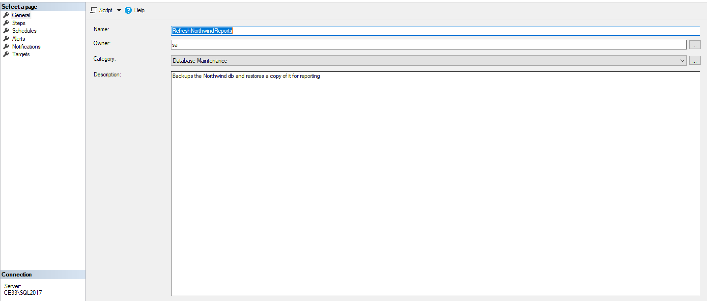

Also, I added the specific step for the job as shown picture below. I first changed name to “Back up Database” and set the type for Transact-SQL script (T-SQL) which allows to communicate with SQL Server. Then, I set the database as “tempdb” for the place where the task of job is operating. I wrote some command that operates the given SQL script of stored procedures.

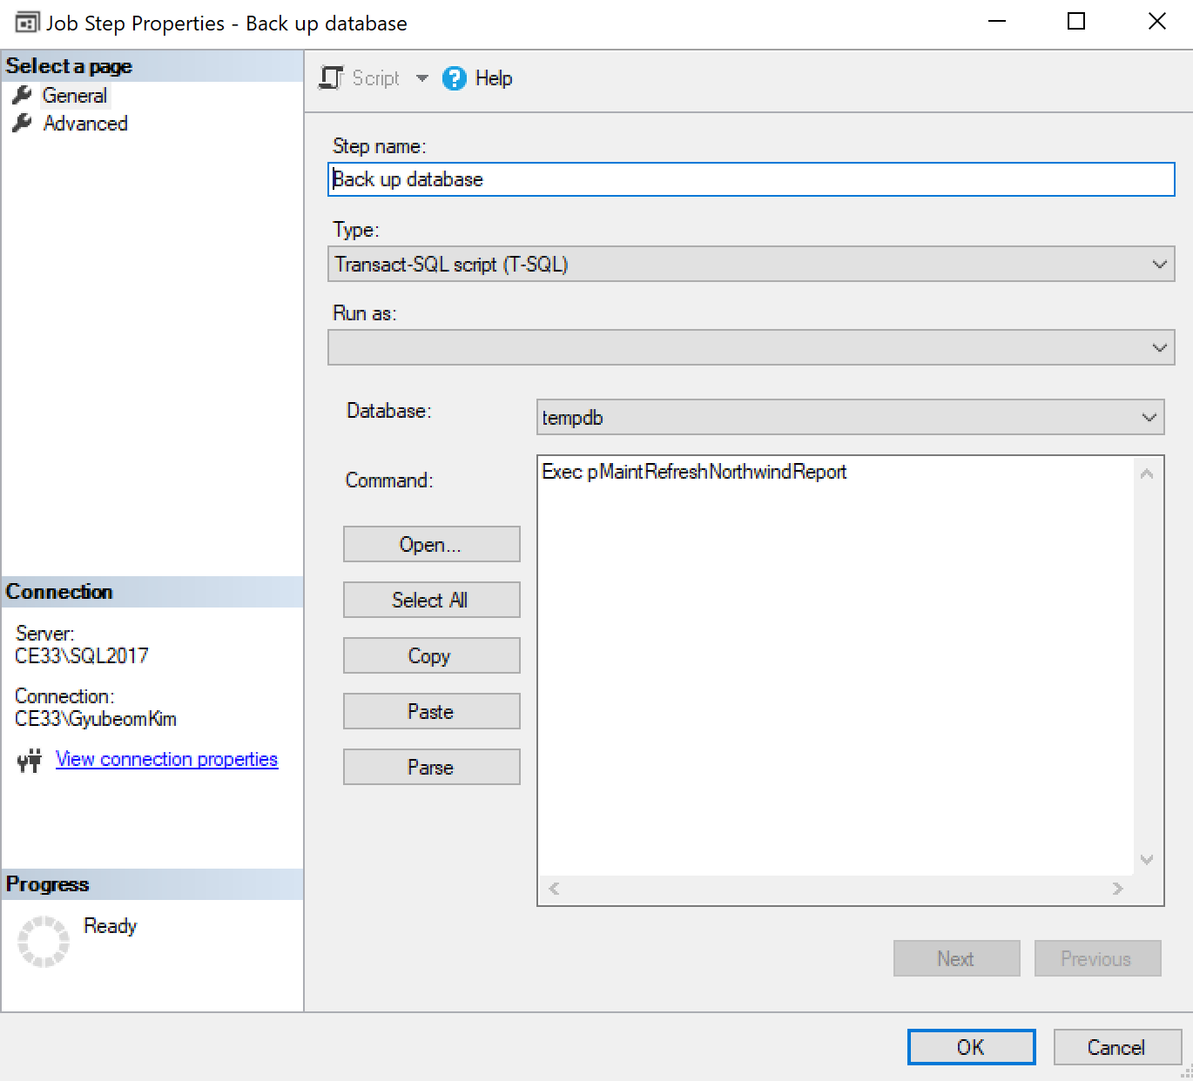

This is the given SQL script for the command.

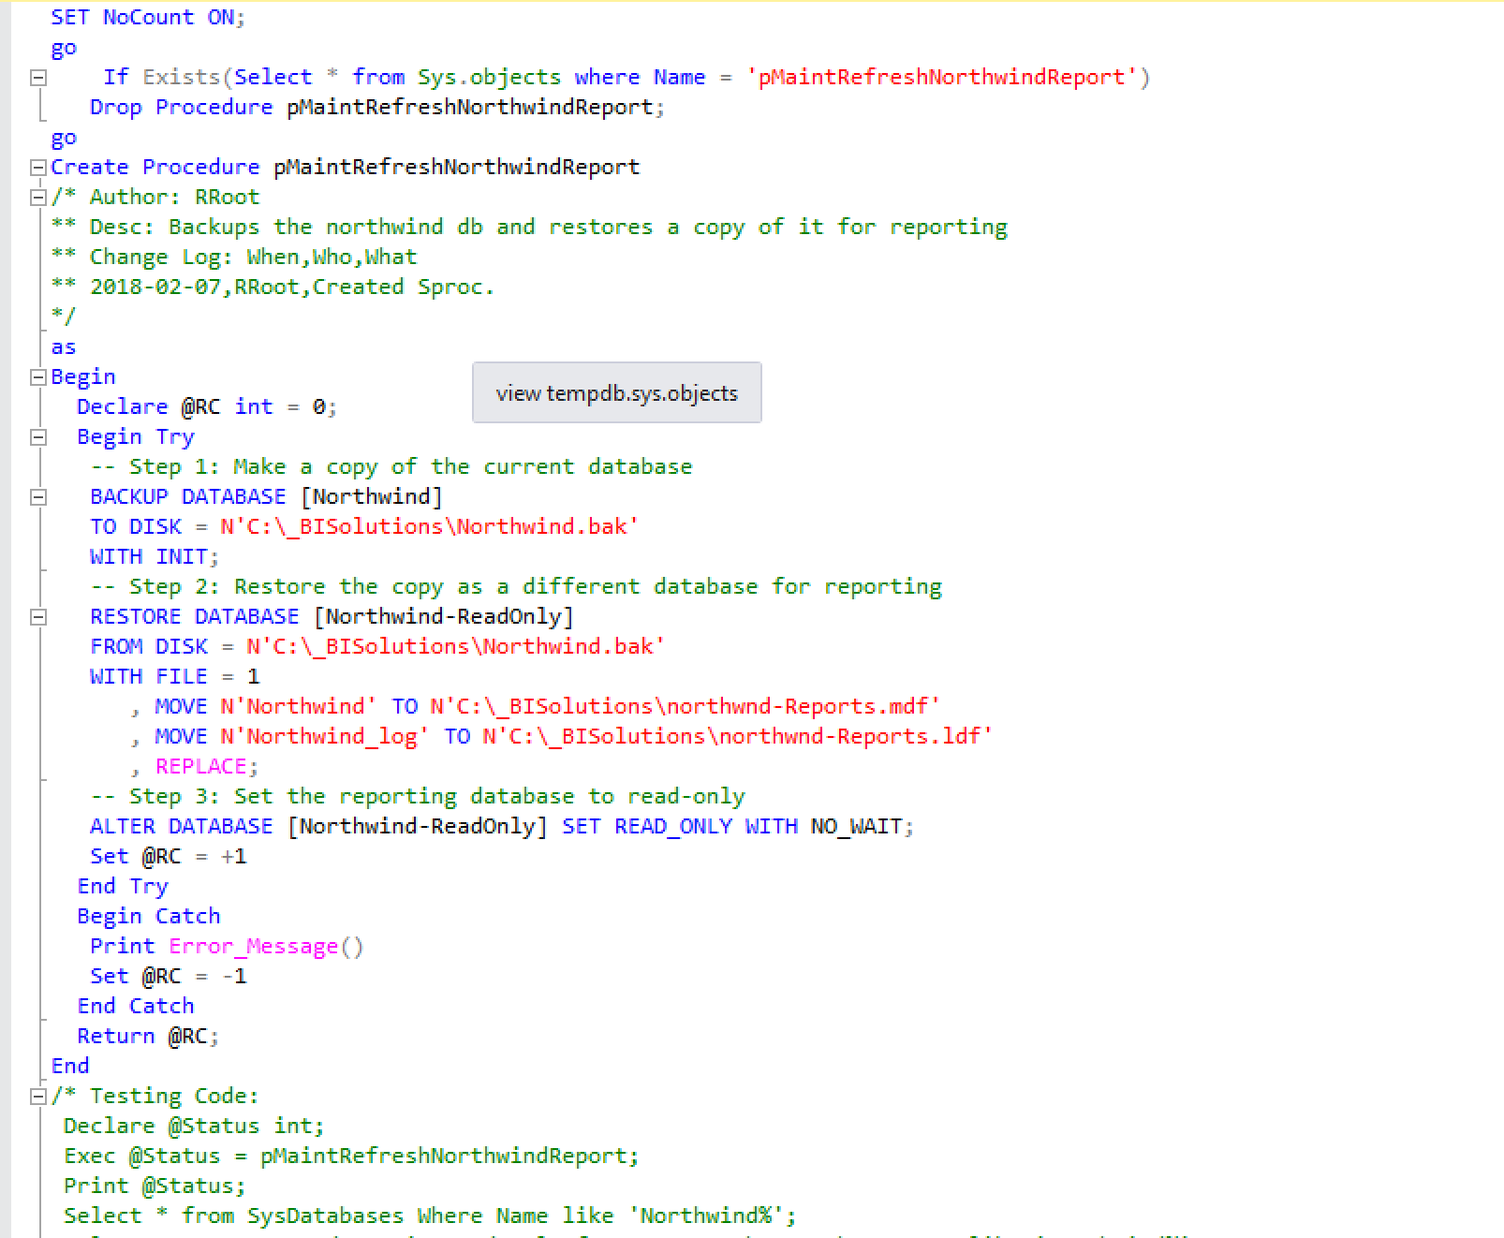

For the last step, I set the schedule for the specific time occurring the job. As you can see the picture below, the job occurs once each day at 12:01 AM.

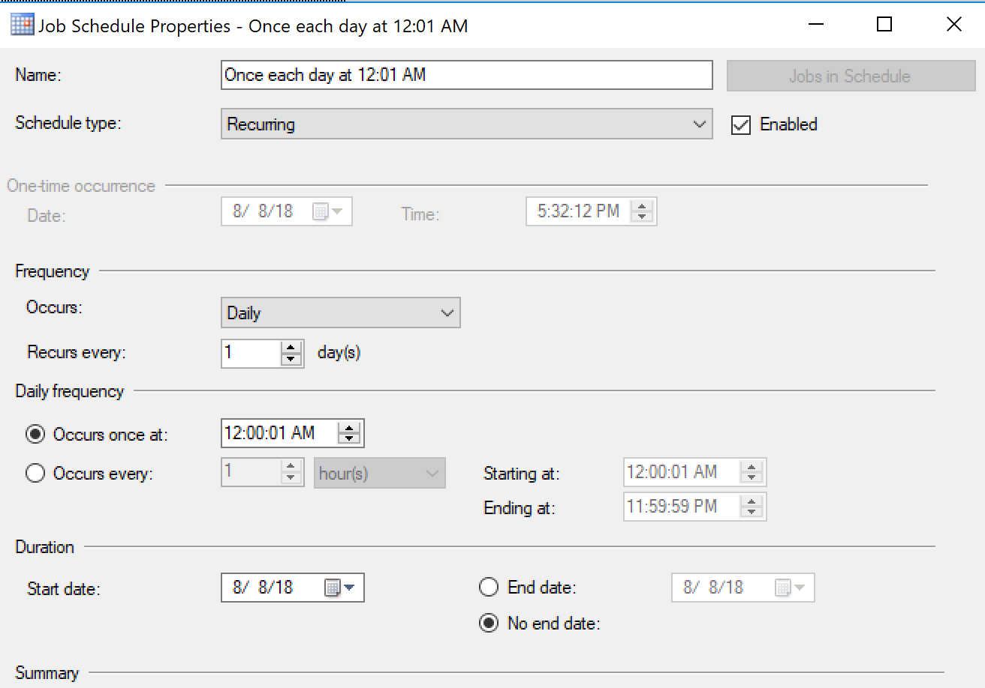

**Start the Created Job and Result (The picture Shown Below):**

After the setting is done, I started to run the job for the created task. Then, I was find the backup file and reports that are created by operating the job.

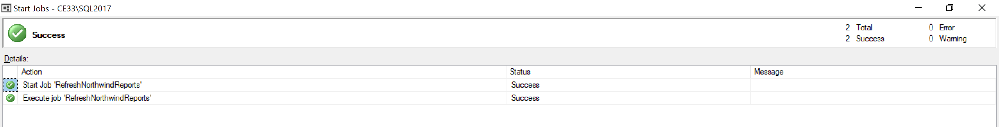

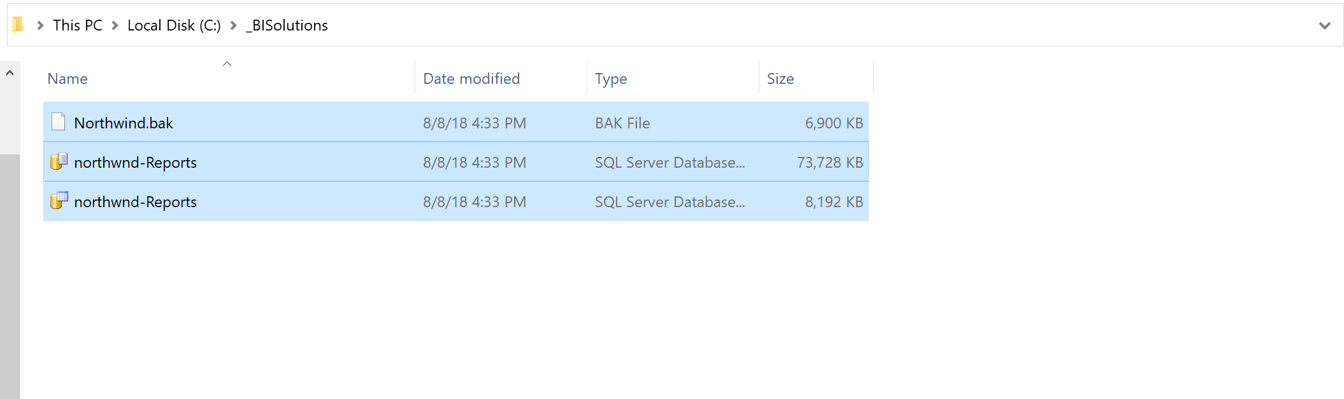

**Summary:**

An SQL Server Agent Job is a specified type of operations in SQL server. A job can perform is able to perform a wide range of activities such as running Transact-SQL scripts, command prompt applications, Microsoft ActiveX scripts, Integration Services packages, Analysis Services commands and queries, or Replication tasks (Creates Jobs, 2018). In the process of using a job, we are able to assign ownership for using it and make a step for conducting specific command as a task of the job. Also, we can run a job repetitively when we set the specific time and get notification of users by creating the option for alerts.

**Work Cited**

Create Jobs. (2018). Retrieved from <https://docs.microsoft.com/en-us/sql/ssms/agent/create-jobs?view=sql-server-2017>

Root, R. (2018). *Module5*